**Brugu Software Solutions – Blog – Page 3**

The NFT marketplace is where cryptocurrencies are used to trade NFTs. The Ethereum blockchain network powers most of these markets. NFT markets have recently attracted the interest of a variety of groups, including investors, developers, and crypto fans. By tokenizing your rare collections to NFTs, an NFT marketplace gives you the chance to boost the price of your items.

**The Benefits of NFT Markets**

**Security:**

Security is a top priority for the NFT platform when it comes to token transfers between market participants. The built-in security guards against transaction loss and other undesirable actions because it is secured by private keys.

**Integrity:**

The blockchain network makes sure that transactions are performed fast and without mistake.

**Decentralization:**

With each new block that is added, the NFT platform network alters its blockchain to account for the changes.

**Smart contract:**

Smart contracts are started by digitally signing an agreement, which prevents fraud and gets rid of commission-free middlemen. Smart contracts are developed using lines of code to automate the process.

As NFT prices surged, several industries, including those in the art and collectibles, gaming, tickets, and metaverse, started establishing their own NFT markets. Setting up a blockchain network, integrating a few digital wallets, generating smart contracts, and developing a web application are some of the essential tasks in starting your own marketplace. Choosing the best blockchain framework is crucial to starting your own marketplace since blockchain is essential to the NFT marketplace's operation.

**NFT Market development company**

Based on how it operates, each blockchain is distinct from the others and has unique benefits and drawbacks. In this article, we go over the top 6 blockchains—Solana, Polkadot, Polygon, Cardano, Flow, and Binance Smart Chain—that are best suited for the creation of NFT marketplaces, as well as the features of the NFT marketplaces—OpenSea, PancakeSwap, CryptoKitties, and others—that are based on these blockchains.

**Solana NFT Marketplace**

The process of building an NFT marketplace on the Solana blockchain with cutting-edge security features that allow people to buy, sell, and trade NFTs in a range of industries including as art, sports, music, gaming, and more is known as "Solana-based NFT marketplace development."

At Brugu Software solutions, we offer a broad range of services, such as the creation of NFT marketplaces, Solana blockchains, and tokens. The Solana blockchain enables any company or entrepreneur to quickly establish the platform they need.

**The Best Solana NFT Marketplaces**

Magic Eden

Solsea

DigitalArt

Solanart

**Why Solana for The NFT Marketplace Development?**

The decentralised nature of Solana, which fully removes middlemen, makes it affordable to build high-performance NFT markets. Each stage is mechanised, which reduces time by doing away with physical labour. Some of the most appealing aspects of Solana that distinguish this platform are its quick transaction times and minimal fees.

The Solana blockchain's native coin is called SOL. In November 2021, SOL reached an all-time high price of $258.93, ranking in the top 10 cryptocurrencies. At that point, Solana attracted the interest of various investors.

**Development of the Polkadot NFT Marketplace**

Polkadot NFT marketplace development is the process of creating a decentralised NFT Marketplace platform on top of the Polkadot blockchain network. A platform built on the Polkadot blockchain makes it simpler for sellers and producers of digital content to use NFTs since it offers improved reliability and can process up to 1000 transactions per second.

Enjin is a colonist for integrating NFT on Polkadot by developing a durable network that enables a permissionless platform, streamlined protocol burden, cross-chain amity, unique impulses, and a completely decentralised platform.

**Top NFT marketplaces in Polkadot**

XENO

POP

NFT MART

**Why Polkadot for NFT Marketplace Development?**

A mechanism for accessing interoperable NFT markets is offered by the Polkadot blockchain. One of the key reasons why business owners choose the Polkadot for the growth of the NFT market is because of its compatibility. Other factors include precise transactions, high scalability, and transparent governance.

**The Growth of Polygon NFT Marketplace**

For bitcoin users who prefer speedy transactions with cheap gas rates, Polygon is the most often used alternative blockchain. The layer-2 protocol created on the Ethereum virtual machine currently has more active addresses than Ethereum due to the millions of users that have joined up for it. The network is praised as a potential Ethereum flipper and already sees daily sums of above $800 million.

The system's main component is Polygon SDK, a sophisticated platform for creating and affixing secured chains that are intended to be rigid and independent. A multi-chain Ethereum ecosystem is created by connecting scalable Ethereum outcomes.

**Top Polygon NFT markets**

Opensea

Trade

Aavegotchi

**Why Polygon?**

**Fast transactions** - Its ability to provide consumers with a simple and rapid payment procedure is one of its main advantages.

**Cost-effective** - The transaction price is incredibly minimal when compared to many other blockchain networks, which is a huge advantage.

**Advanced security** - It strengthens the platform's security using its own algorithm.

**Compatibilit**y — Users may trade NFTs from a number of side chains using this platform.

**Development of the Cardano NFT Marketplace**

Third-generation public blockchain Cardano is quickly gaining acceptance. As Ethereum blockchain develops into a more significant form, Cardano blockchain has shown to be a strong rival. Cardano conducts transactions at a pace of 257 per second. Due to the poor selling, a lot of investors are turning to Cardano to launch their own marketplace.

After Mary Hard Fork, in March 2021, Tokhun was established as a Cardano-based NFT Marketplace. Tokhun started off as a platform for creating NFTs, but it swiftly developed into an NFT marketplace powered by smart contracts.

**Top Cardano NFT Marketplaces:**

CNFT

Tokhun

Advisor

Galaxy of the heart

**Why Develop the Cardano NFT Marketplace?**

Owners of NFT marketplaces on Cardano have a number of different options to benefit from their businesses. For instance, there are charges for each transaction made on the marketplace. Additionally, they receive payment for placing advertisements on the market.

As a result of the interoperable packages of the NFT, users can get rapid liquidity. NFT dealers can immediately purchase or sell an asset after completing a transaction on the Cardano blockchain. Starting a Cardano-grounded NFT corporation allows for quick liquidity due to the quiet interval between transactions.

The NFT market is operated on the Cardano blockchain, which is renowned for its security and adaptability. The NFT business's data is safe because of its distributed servers and decentralised architecture.

**Flow NFT Marketplace Development**

The entire process of developing an NFT company for art, games, music, real estate, etc. on the Flow blockchain is called Flow NFT Marketplace Development. It enables the construction of native tokens and the integration of smart contracts on the Flow network.

It is an extremely unique and cutting-edge blockchain for NFTs that enables scalable and affordable NFT minting and trading. This enables covering these tiny expenses and permits minting and trading on the Flow blockchain at no cost.

**Top NFT marketplaces on Flow:**

CryptoKitties

Top Expo

NBA Top Shot

**Why Do You Want to Develop An NFT Marketplace With Flow?**

Specifically Launched For NFTs

Reduces sluggishness

High efficacy

Low sales figure

High speed

**Development of the Binance Smart Chain NFT Marketplace**

The production, purchase, bidding, and sale of digital collectibles on the Binance Smart Chain are carried out through an interconnected process known as the Binance Smart Chain-based NFT marketplace (BSC).

BSC's Top NFT Marketplaces:

Smart chain (BSC) network

BattleFaves

PancakeSwap

**Why Should NFT Marketplace Development Use Binance Smartchain?**

The price of delivering an NFT business outcome on the Binance Smart Chain is influenced by a number of factors (BSC). It depends on the tools and technologies used, the level of platform harmony, the kind of essential and extremely costly features, the time given, and the amount of money spent on the blockchain formulators.

Each blockchain has unique characteristics, advantages, and downsides. The best NFT marketplace for your company will rely on a number of variables and be unique to each person. Therefore, it's crucial to locate someone who can guide you in picking the best blockchain for the creation of your NFT marketplace.

**Grammarly screenshot:**

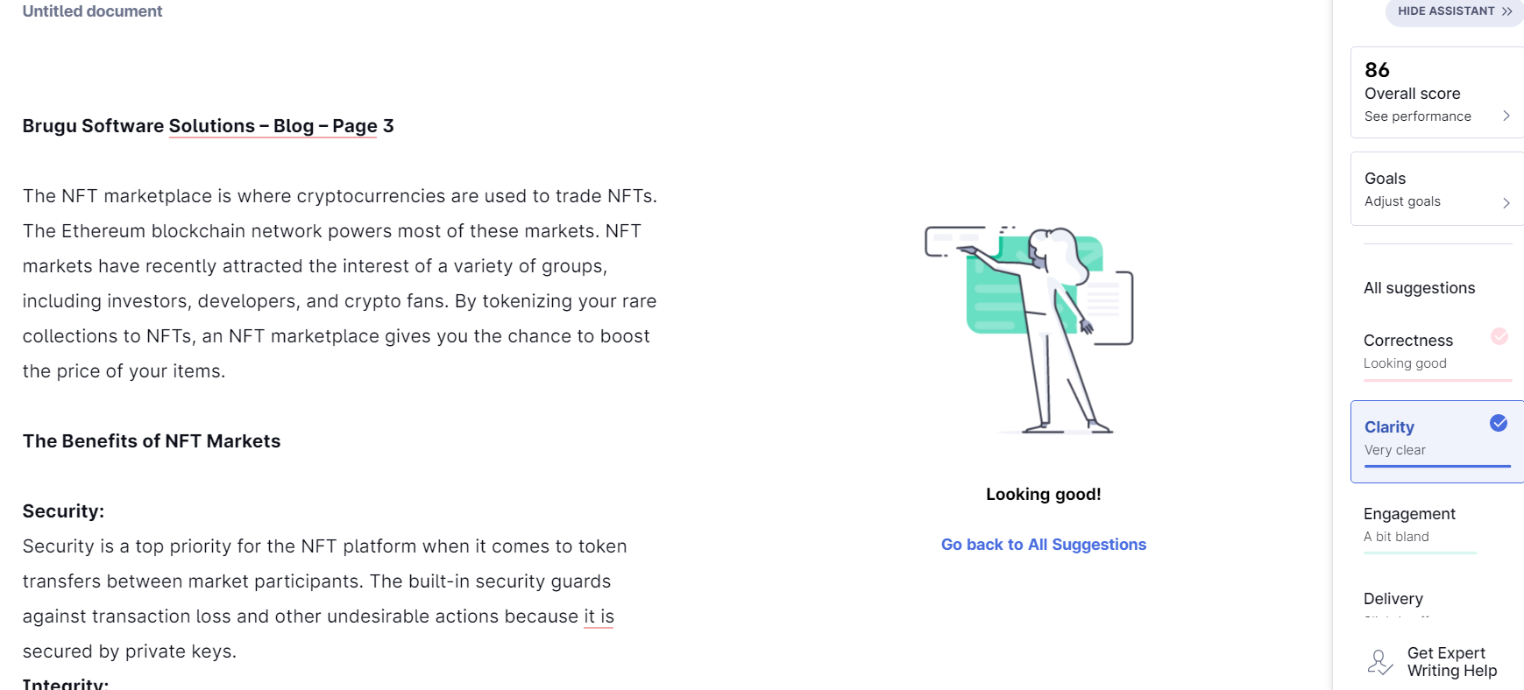

**Plagiarism screenshot:**

